Class B Audio Amplifier Project
using a complementary push-pull transistor configuration
Team Members:
Menna Elrahman Mohamed
Hany Ehab
Tasneem Abdelrahman

Under supervision:
Dr / mostafa wageeh
Dr / Mohammed tawheed
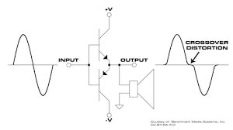

Abstract:
This project presents the development of a Class B audio amplifier designed to efficiently amplify analog signals using a push-pull transistor configuration. Class B amplifiers are widely used in audio applications due to their high efficiency, which is achieved by activating each transistor for only one half of the input waveform.
The amplifier circuit employs complementary NPN and PNP transistors (TIP31 and TIP32) to handle the positive and negative halves of the waveform, along with supporting components such as resistors and capacitors for signal conditioning and stability.
Introduction:
Amplifiers are fundamental components in electronics, used to increase the amplitude of electrical signals for various applications ranging from communication systems to audio devices. They are classified into different classes—A, B, AB, C, and others—based on how the output devices (transistors) conduct during a signal cycle.
This project centers around the Class B amplifier, which is known for its high efficiency and relatively simple design. Unlike Class A amplifiers, where the output device conducts throughout the entire input cycle, Class B amplifiers use two complementary transistors—one handling the positive half of the input signal and the other handling the negative half. This push-pull configuration allows for significant power savings and reduced heat generation.
However, Class B amplifiers come with a notable drawback: crossover distortion, which occurs around the zero-crossing point of the signal where neither transistor conducts fully. This issue affects audio quality, especially in low-amplitude signals.
Circuit Configuration:
The Class B amplifier used in this project is built around a push-pull configuration that employs two complementary transistors — TIP31 (NPN) and TIP32 (PNP). These transistors work alternately to amplify different halves of the input signal: TIP31 handles the positive half, while TIP32 handles the negative half.
To ensure stable operation, the circuit includes resistors for current limiting and biasing, and capacitors for input and output coupling as well as filtering. A 0.5-ohm resistor is used in series with each emitter to help balance the current and reduce crossover distortion. The power supply used is typically 12V DC, and the output is connected to a speaker load for testing.
Working principle:
In a Class B amplifier, the input signal is split into two half-cycles:
- The positive half is amplified by the NPN transistor.
- The negative half is amplified by the PNP transistor.
This division of labor between the two transistors reduces the amount of time each transistor is active, which in turn reduces power consumption and heat generation compared to Class A amplifiers.
However, without biasing, both transistors are off during the transition near zero volts, causing distortion. To overcome this, the circuit can be biased slightly so that both transistors are slightly conducting near zero, effectively turning it into a hybrid between class B and Class AB configuration for better linearity.
Crossover Distortion:
Crossover distortion is a major drawback of pure Class B amplifiers. It occurs when the signal transitions through the zero-voltage point, and neither transistor is conducting for a brief moment. This results in a notch or gap in the output waveform, especially noticeable in audio applications.
To reduce this distortion:
- A small bias voltage is applied between the base-emitter junctions of the transistors.
- Emitter resistors are used to provide local negative feedback, helping balance the conduction and smooth the signal.
Advantages and Disadvantages:
Advantages:
- High Efficiency (up to 78.5%) compared to Class A.
- Reduced Power Loss, since each transistor conducts for only half the cycle.
- Lower Heat Generation, reducing the need for heavy heatsinks.
Disadvantages:
- Crossover Distortion affects audio fidelity.
- Complex Biasing Requirements to reduce distortion.
- More Complex Design compared to Class A, especially if adding feedback or filters.
Components:
Transistor (NPN / PNP)
---> Amplifies positive and negative half of the input signal
Voltage divider
---> divide the Vcc voltage to suit the amplifier circuit
Biasing resistance
---> keep the class B transistors in the active region
DC analysis:
Rth = 10 / (22k + 10k) = .3125Ω
Vth = Vcc * Rth = 12 × .3125 = 3.75V
VE = Vth - VBE = 3.75V - 0.7V = 3.05V
IE = VE / RE = 3.05 / 330 = 9.24 mA
Assuming β = 100 for 2N3904:
α = β / (β + 1) = 100 / 101
→ IC ≈ α × IE
→ IB = IE - IC = 9.24 mA - 9.15 mA = 0.09 mA

→ KVL:
12 - (9.15×10⁻³ × 390) - VCE - (9.24×10⁻³ × 330) = 0
→ VCE = 5.38V
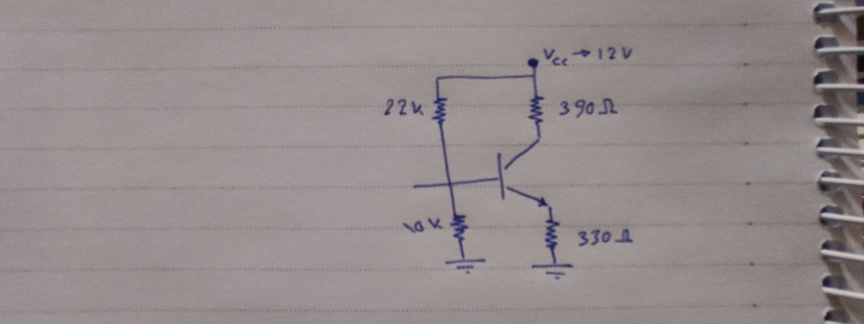
→ VCE > 0.7 → transistor in Active region
AC analysis:
rπ = β / gm → gm = Ic / VT = 9.15 × 10^-3 / 25 × 10^-3 = 0.366 S
rπ = 100 / 0.366 = 273.22 Ω
Rin = (1/10k + 1/22k + 1/273.22)^-1 = 262.78 Ω
ib = Vin / Rin = 0.2 / 262.78 = 7.611 × 10^-4 A
ic = β * ib = 7.61 × 10^-4 × 100 = 76.1 mA
Vout = -ic × Rc = -76.1 × 390 × 10^-3 = -29.679 V

Av = -gm * Rc = -0.366 * 390 = -142.74
References:
- ELECTRONIC DEVICES Electron Flow Version Ninth Edition (Thomas L. Floyd)
- Sedra & Smith, Microelectronic Circuits seventh edition .
- Project Simulation and Team Research Documentation.
- Doctors lectures and sections

